News Release
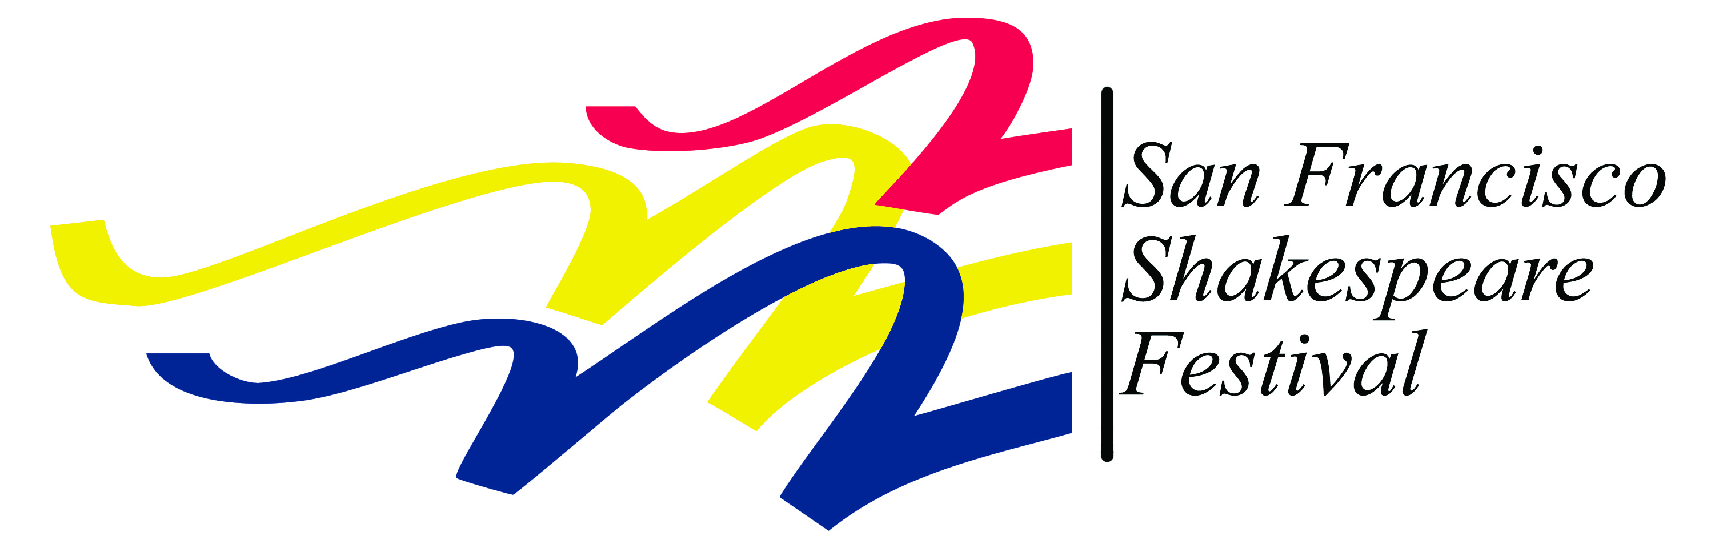

Media Contact Only:
John Western, Marketing Director
415/865-4422
jwestern@sfshakes.org

FOR IMMEDIATE RELEASE
May 29, 2015

33rd season of Free Shakespeare in the Park presents “Romeo and Juliet”
June 27 - September 27 in Pleasanton, Cupertino, Redwood City and San Francisco
San Francisco, CA – The San Francisco Shakespeare Festival presents Romeo and Juliet for its 33rd season of Free Shakespeare in the Park. The season begins at Pleasanton’s Amador Valley Community Park, with performances June 27-July 12 on Saturdays and Sundays at 7:30 pm, with the Saturday, July 4 show re-scheduled for Thursday, July 2. The show then moves to Cupertino’s Memorial Park, with performances July 18-August 2 on Fridays, Saturdays and Sundays at 7:30 pm. Next up are performances on the park-like grounds of Redwood City’s historic Sequoia High School. Redwood City shows are scheduled August 8-23 on Saturdays at 7:30 pm and Sundays at 4:00 pm. The show then moves to San Francisco’s Presidio for shows August 29-September 13, on Saturdays, Sundays and Labor Day Monday at 2:00 pm. The season closes in San Francisco at McLaren Park’s Jerry Garcia Amphitheater, with shows September 19-27 on Saturdays and Sundays at 2:00 pm.
The Festival’s first Free Shakespeare in the Park production of Romeo and Juliet since 1992 will celebrate Shakespeare’s remarkable genre-defying play, which soars to the heights of romantic comedy before plunging into heartbreak. The title characters will be played by Festival Resident Artists, Carl Holvick-Thomas and Lauren Spencer.
Additional cast members include Festival favorites Sean Garahan, Phil Lowery, David E. Moore, Carla Pantoja and Valerie Weak. Talented newcomers to the Free Shakes stage include Michael J. Asberry, Gwen Loeb, Regina Morones and Mohammad Shehata.
Artistic Director Rebecca J. Ennals continues her historically-based, thoughtfully relevant approach to Shakespeare’s plays with this beloved favorite, filled with some of Shakespeare’s most beautifully poetic language. While the doomed lovers will always be remembered for their romantic devotion, this tale of five young lives needlessly wasted could have come straight from today’s Twitter or Facebook feeds. A culture of violence, inherited from past generations, leads young people to harbor meaningless prejudices and commit terrible acts. Shakespeare’s young characters live secret lives unknown to their parents, and love, kill, and die without most of the older generation knowing why. How does a community recover from a culture of violence? Shakespeare leaves us with the possibility of hope and healing,
a message much needed today.
Audiences can further their enjoyment of this production by attending a 15-minute Green Show (30 minutes before the performance), which provides context and historical background for the play in a fun, family-friendly format.

“Come and crush a cup of wine” with us and bring your family and friends, a blanket and a picnic to enjoy professional theater at no charge in a beautiful park setting!

2015 Performance schedule for Romeo and Juliet:

Pleasanton’s Amador Valley Community Park, Santa Rita Rd and Black Avenue
- Saturday, June 27 at 7:30 pm - Preview
- Sunday, June 28 at 7:30 pm – Opening
- Thursday, July 2 at 7:30 pm
- Sunday, July 5 at 7:30 pm
- Saturday, July 11 at 7:30 pm
- Sunday, July 12 at 7:30 pm

Cupertino’s Memorial Park Amphitheater, Stevens Creek Blvd and Mary Avenue
- Saturday, July 18 at 7:30 pm - Preview
- Sunday, July 19 at 7:30 pm - Opening
- Friday, July 24 at 7:30 pm
- Saturday, July 25 at 7:30 pm
- Sunday, July 26 at 7:30 pm
- Friday, July 31 at 7:30 pm
- Saturday, August 1 at 7:30 pm
- Sunday, August 2 at 7:30 pm

Redwood City, grounds of Sequoia High School, 1201 Brewster Avenue at Broadway
- Saturday, August 8 at 7:30 pm – Preview
- Sunday, August 9 at 4:00 pm – Opening
- Saturday, August 15 at 7:30 pm
- Sunday, August 16 at 4:00 pm
- Saturday, August 22 at 7:30 pm
- Sunday, August 23 at 4:00 pm

San Francisco’s Presidio, Main Post Parade Ground Lawn
- Saturday, August 29 at 2:00 pm - Preview
- Sunday, August 30 at 2:00 pm - Preview
- Saturday, September 5 at 2:00 pm - Opening
- Sunday, September 6 at 2:00 pm
- Monday, September 7 (Labor Day) at 2:00 pm
- Saturday, September 12 at 2:00 pm
- Sunday, September 13 at 2:00 pm
San Francisco’s McLaren Park, Jerry Garcia Amphitheater, 40 John F. Shelley Drive
- Saturday, September 19 at 2:00 pm
- Sunday, September 20 at 2:00 pm
- Saturday, September 26 at 2:00 pm
- Sunday, September 27 at 2:00 pm
Admission is free. For more information, call the San Francisco Shakespeare Festival at (415) 558-0888 or visit www.sfshakes.org
# # # # #

Note to Editor: Artists and staff are available for interviews at (415) 558-0888.
Publicity photos available at
About San Francisco Shakespeare Festival
The mission of the San Francisco Shakespeare Festival is to make the words and themes of Shakespeare available to everyone, regardless of age, ethnicity, financial status, or level of education. We accomplish this through the presentation of Free Shakespeare in the Park and a wide array of education programs: Shakespeare On Tour, Tailor-Made Residencies, Bay Area Shakespeare Camps, Midnight Shakespeare, and Shakespeare for All. Shakespeare On Tour performs an abridged Shakespeare play at schools, libraries, and community centers all over the state. Tailor-Made Residencies connects teaching artists with classroom teachers for in-class theatre enrichment, specifically tailored to their learning objectives and their students. Bay Area Shakespeare Camps for
ages 4-6, 7-13 and 12-18 are two-week theatre camps held throughout the Bay Area. Midnight Shakespeare, the Festival’s after-school program for under-served and low-income youth, serves participants in San Francisco, Oakland, San Jose and Antioch. Shakespeare For All in three Central Valley communities, Salida, Madera, and Chowchilla, gives residents a chance to stage community productions of Shakespeare’s plays with the assistance and guidance of theater professionals.

About Rebecca J. Ennals
Ennals, who took the position of Artistic Director in 2012, has been a staff member of the San Francisco Shakespeare Festival since 2002. She has extensive acting, directing and teaching experience and holds a BA in Theatre and English from Scripps College (summa cum laude) and an MFA in performance from U.C. Davis. Bay Area directing credits include productions at Peninsula Youth Theatre, Los Altos Youth Theatre, California Conservatory Theatre-San Leandro, Pear Ave. Theatre, PlayGround (where she is a company member), Shakespeare at Stinson Beach, Napa Valley Shakespeare Festival, and Napa Valley Repertory Theatre. For the San Francisco Shakespeare Festival, she has directed The Taming of the Shrew for Free Shakespeare in the Park, eight Shakespeare on Tour productions and various projects including Romeo and Juliet for Napa’s Festival del Sole, numerous Free Shakespeare in the Parklet playlets (a program she devised), and the 2013-14 Green Shows at Free Shakespeare in the Park.

